6.99: a) 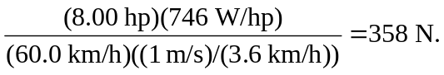

b) The extra power needed is

so the total power is 47.2 hp. (Note: If the sine of the angle is approximated by the tangent, the third place will be different.) c) Similarly,

This is the rate at which work is done on the car by gravity. The engine must do work on the car at a rate of 4.06 hp. d) In this case, approximating the sine of the slope by the tangent is appropriate, and the grade is
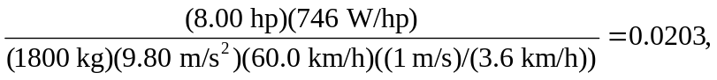

very close to a 2% grade.

